Configure and Connect a MySQL Database Instance with a Web Server

* Open AWS Console

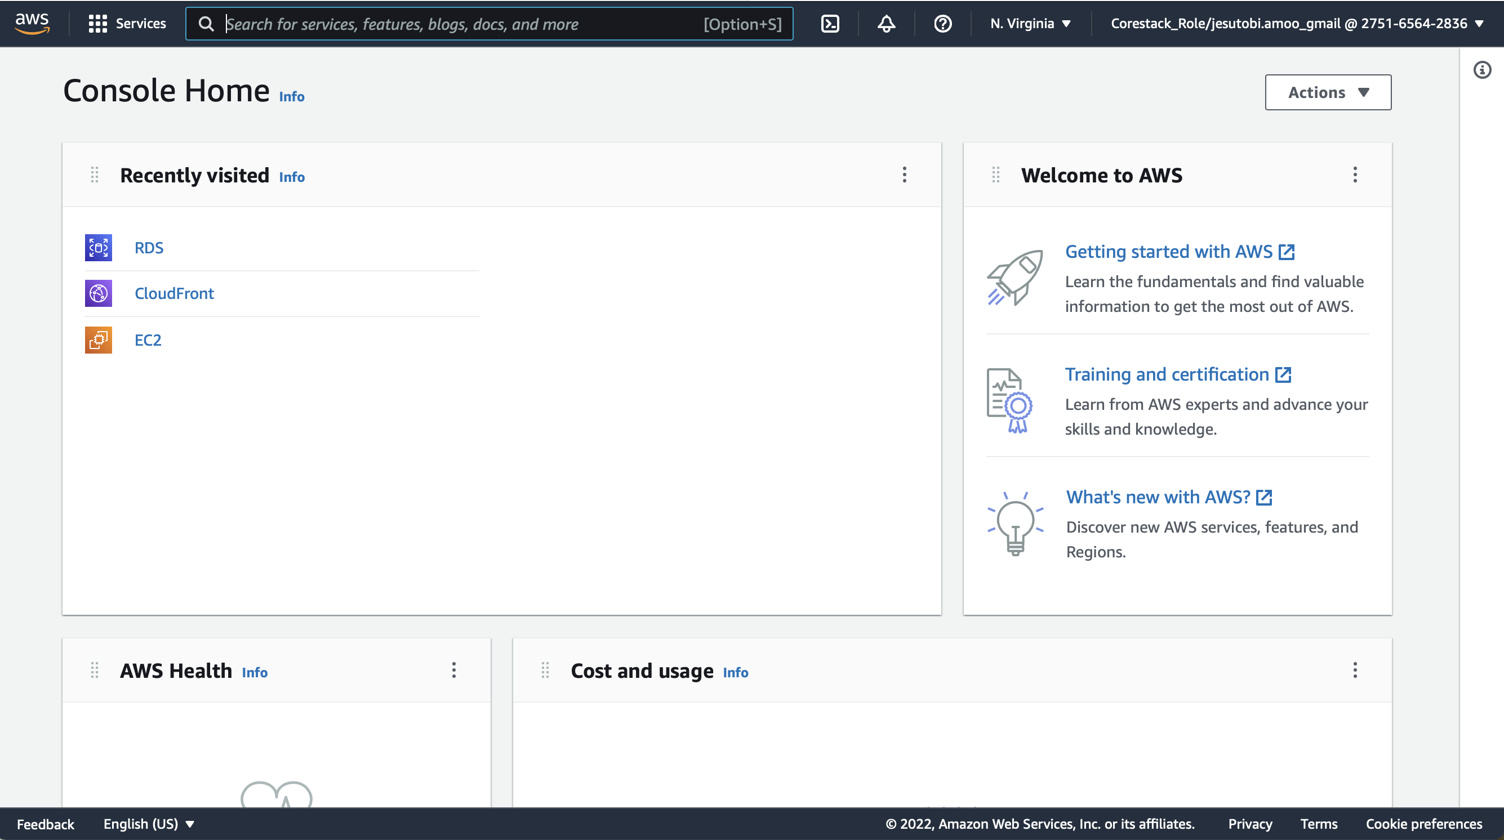

* Navigate to Database on the left panel

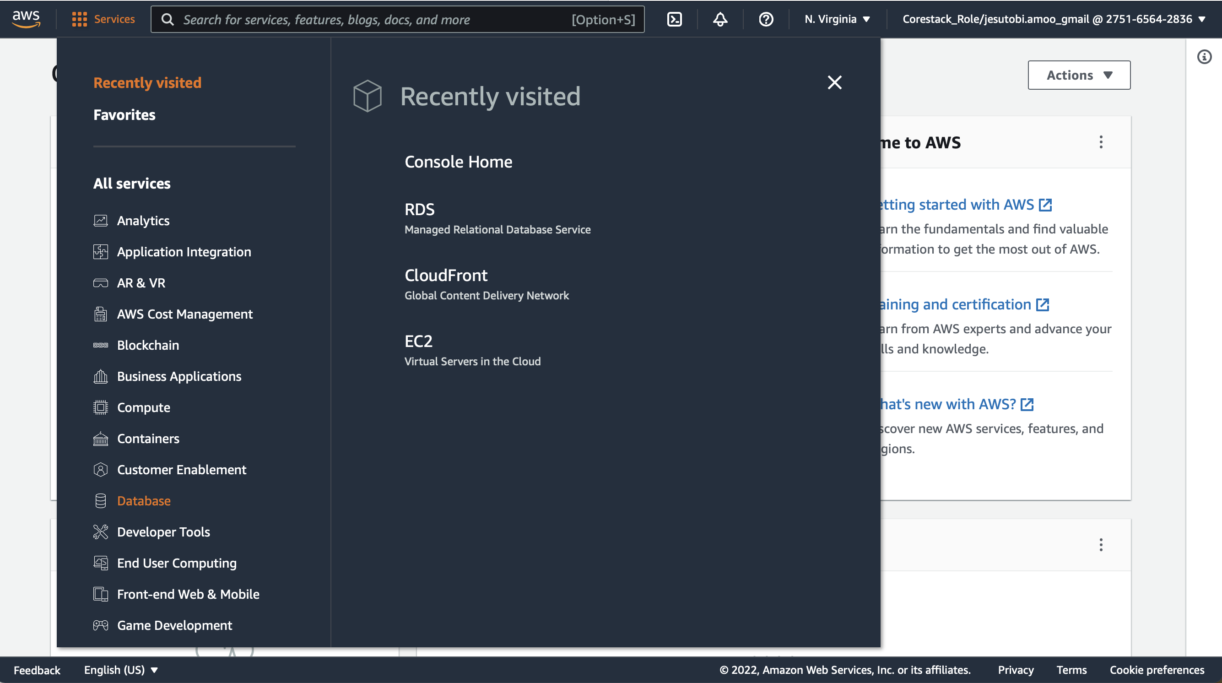

* Click on RDS

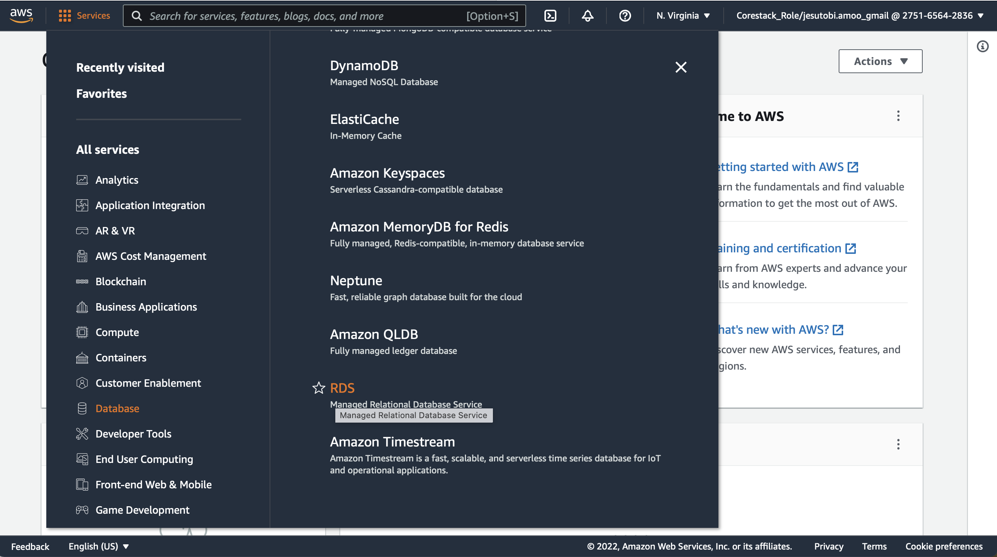

* Click on Create Database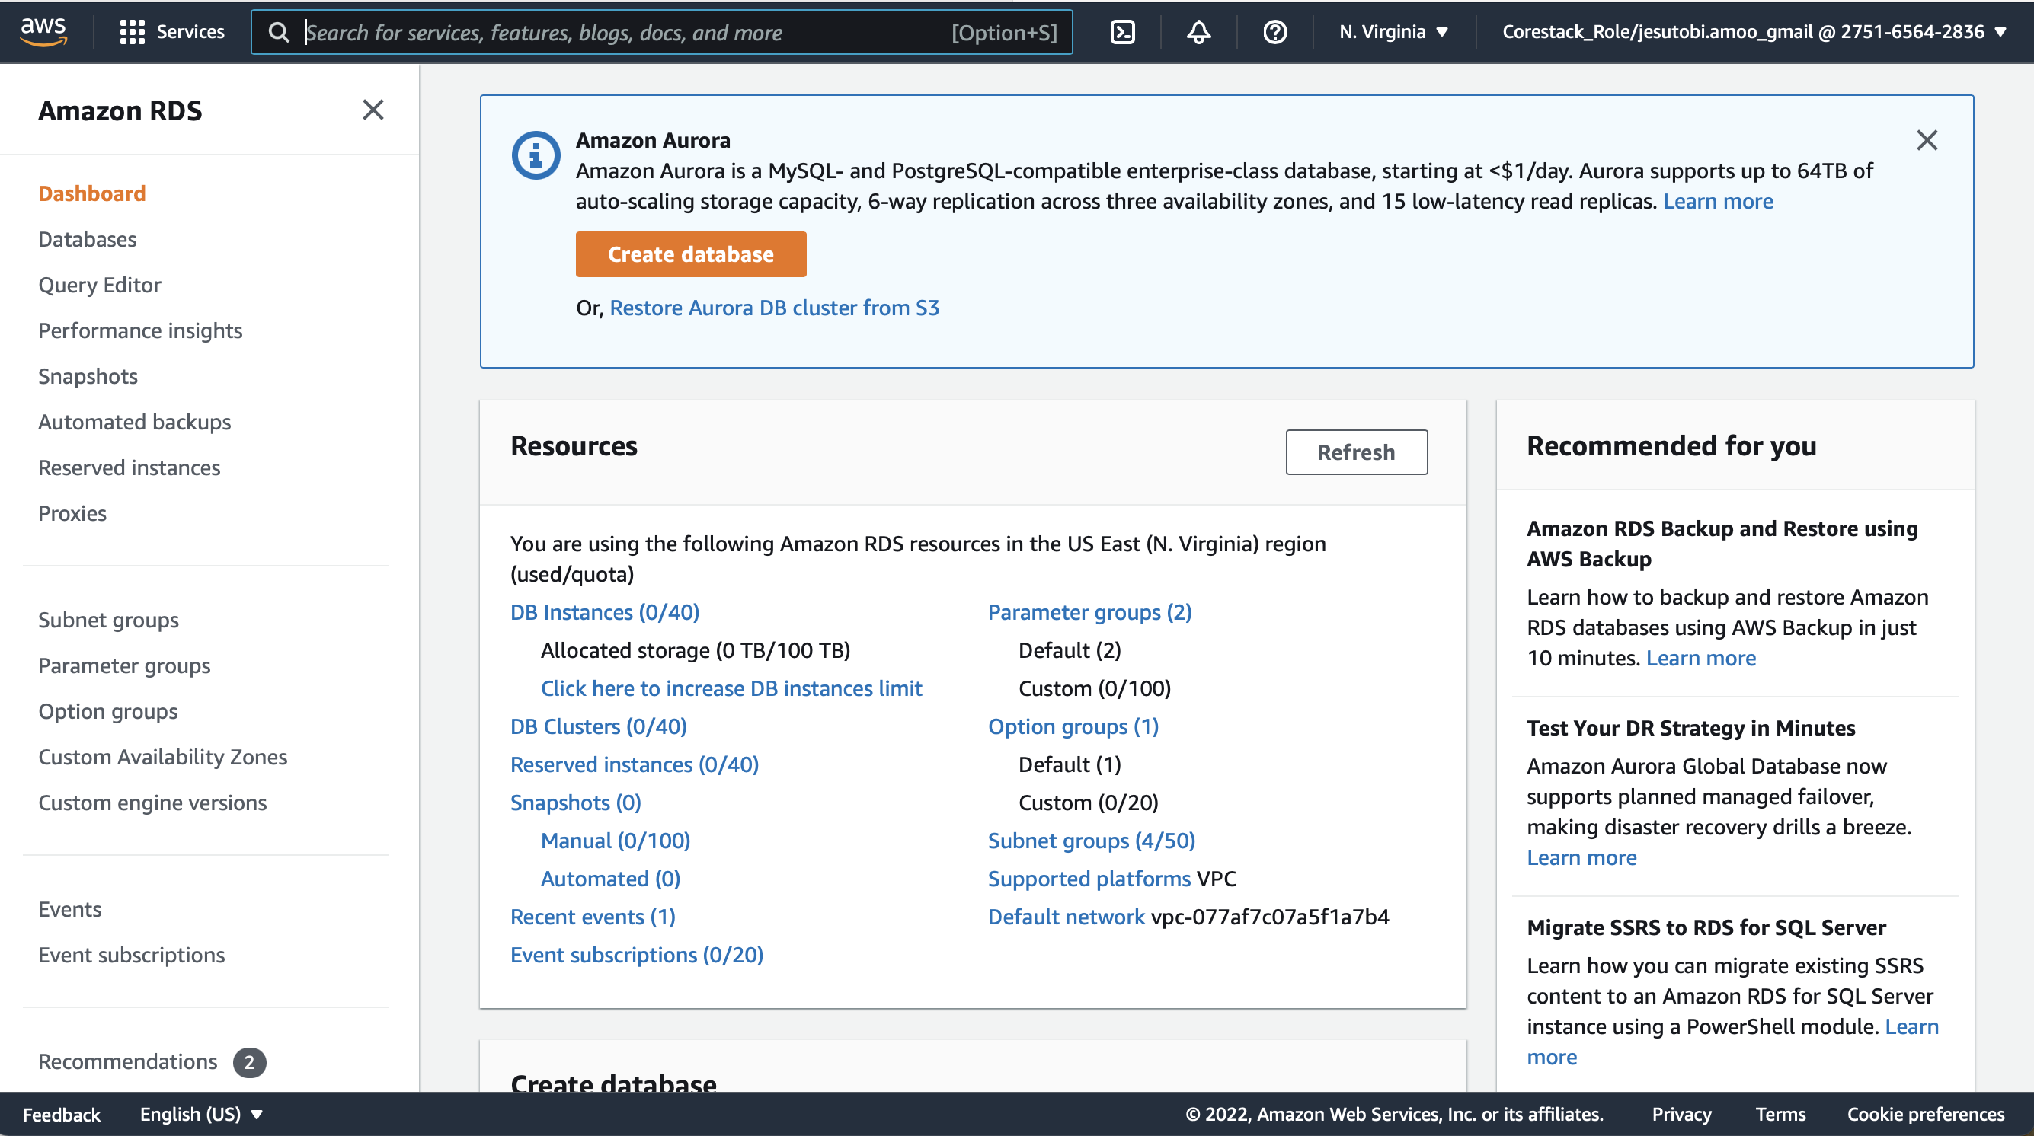
* Select Standard Create and MySQL engine

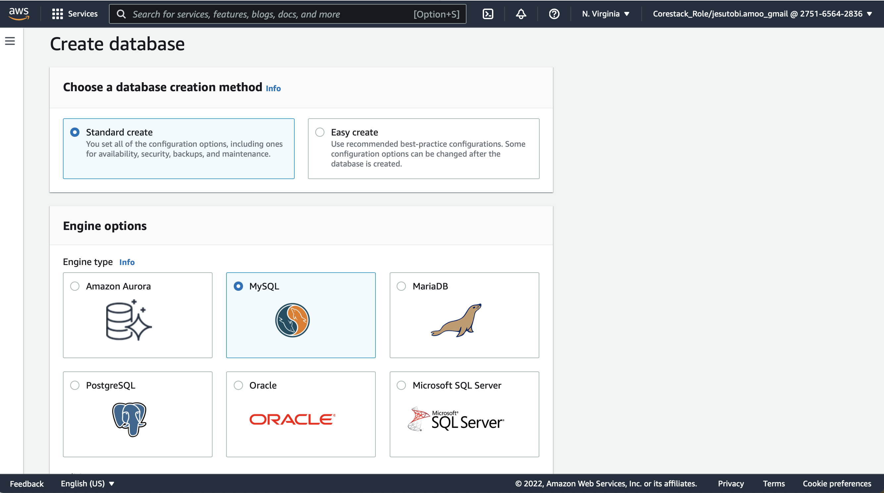

* Select Free Tier template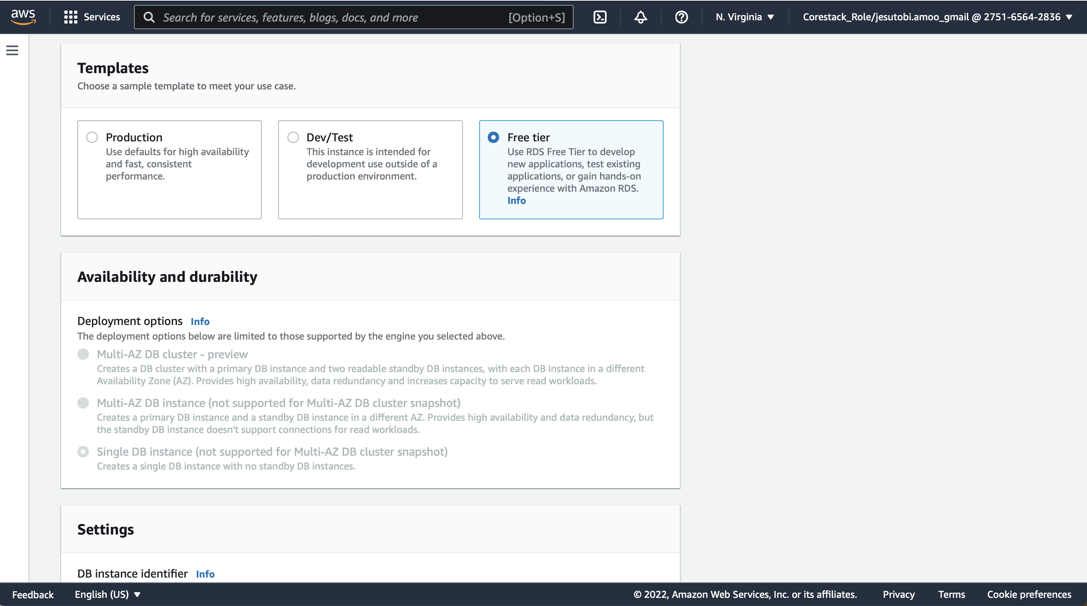
* Choose DB instance identifier, master username and password

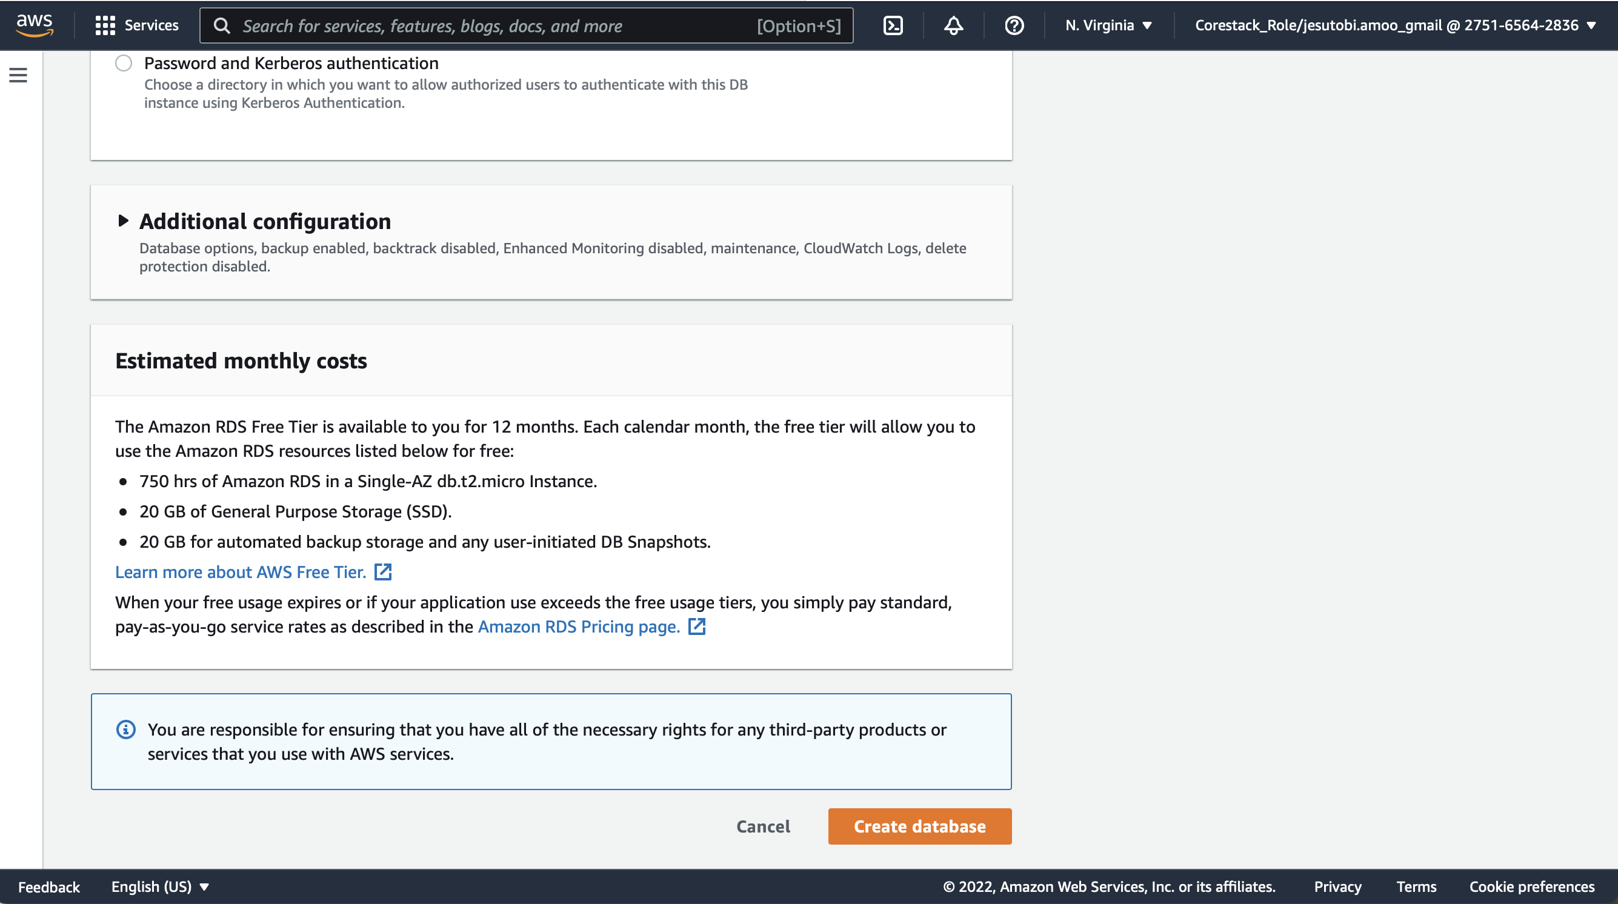

* Click on Create Database

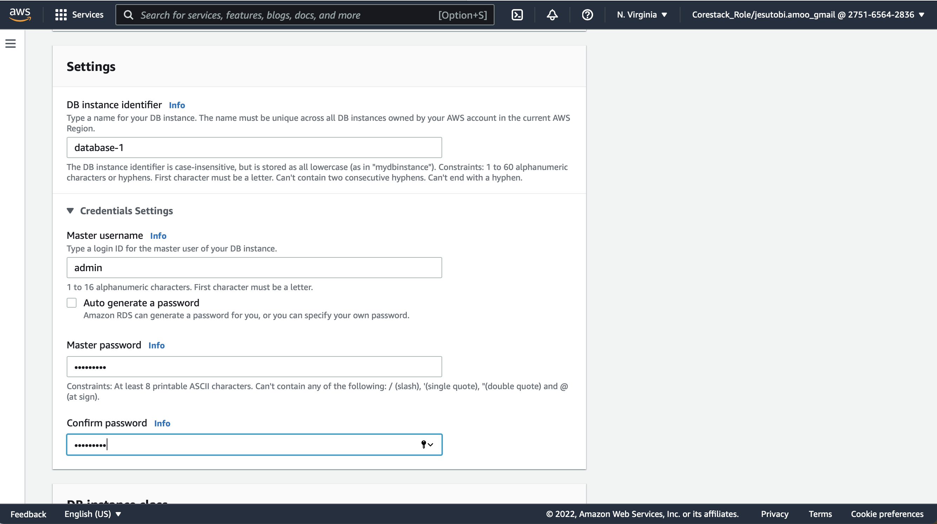

* Wait a few minutes for the database to be created

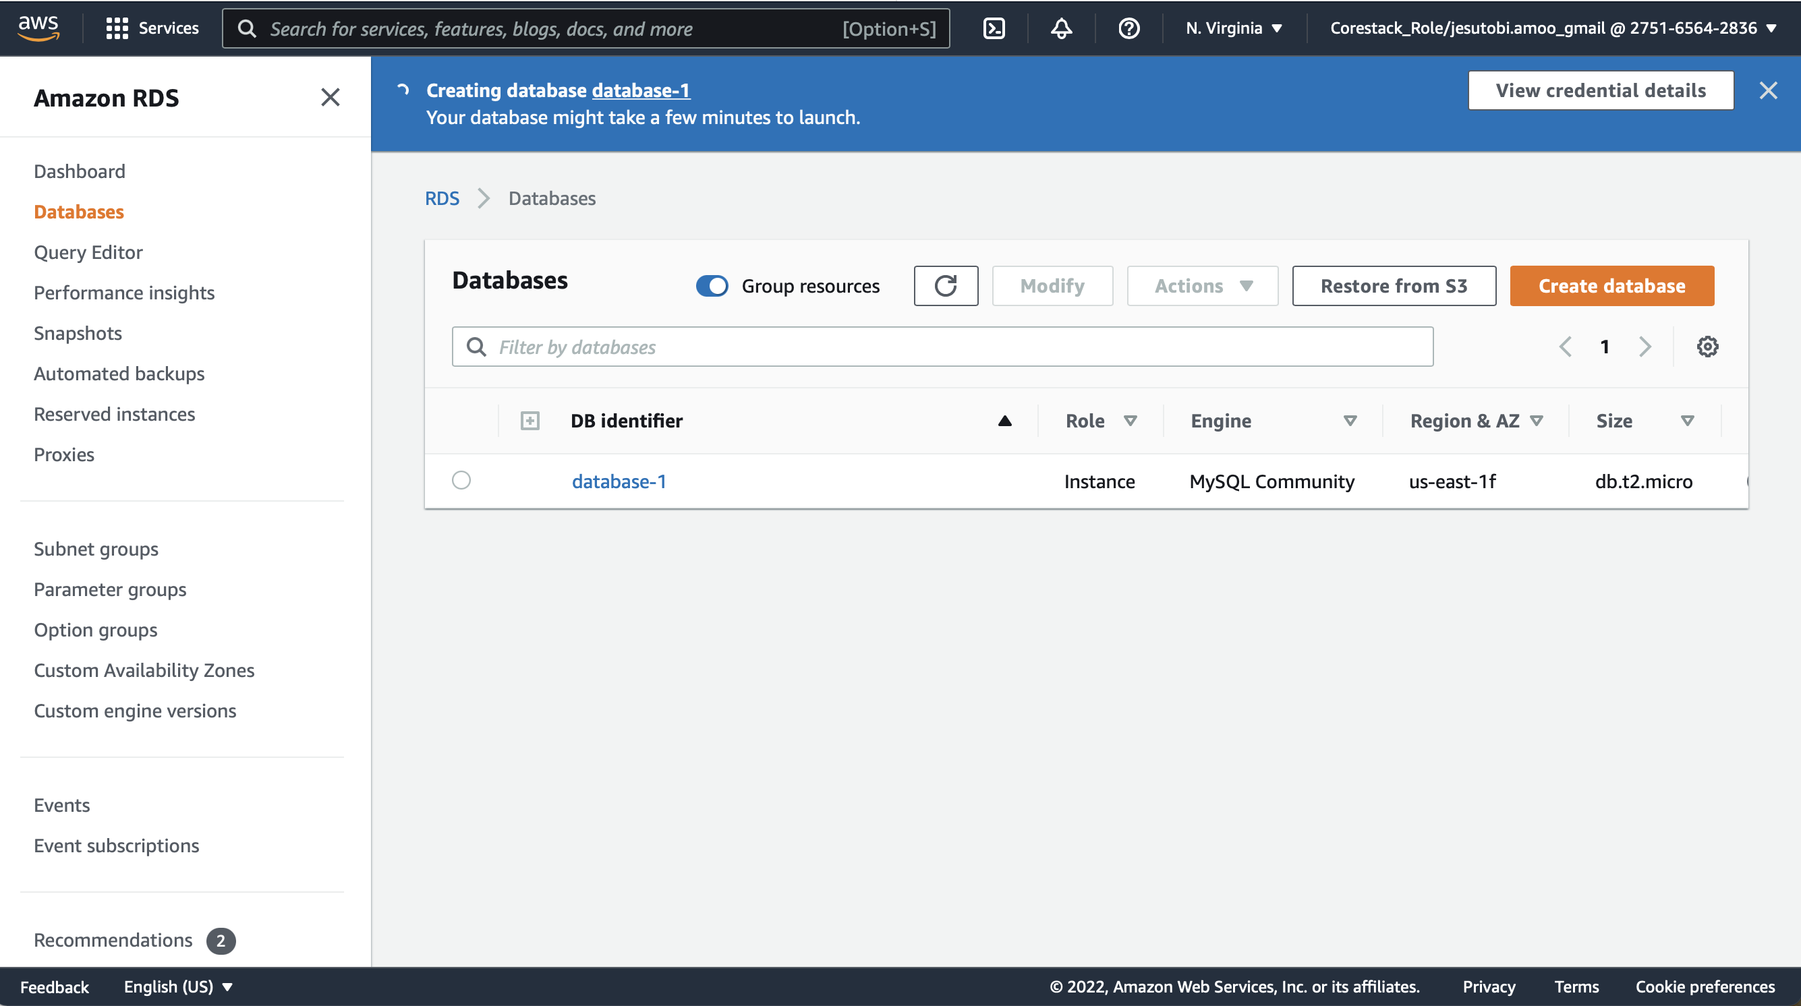

* Open EC2 on a separate tab and Launch Instances

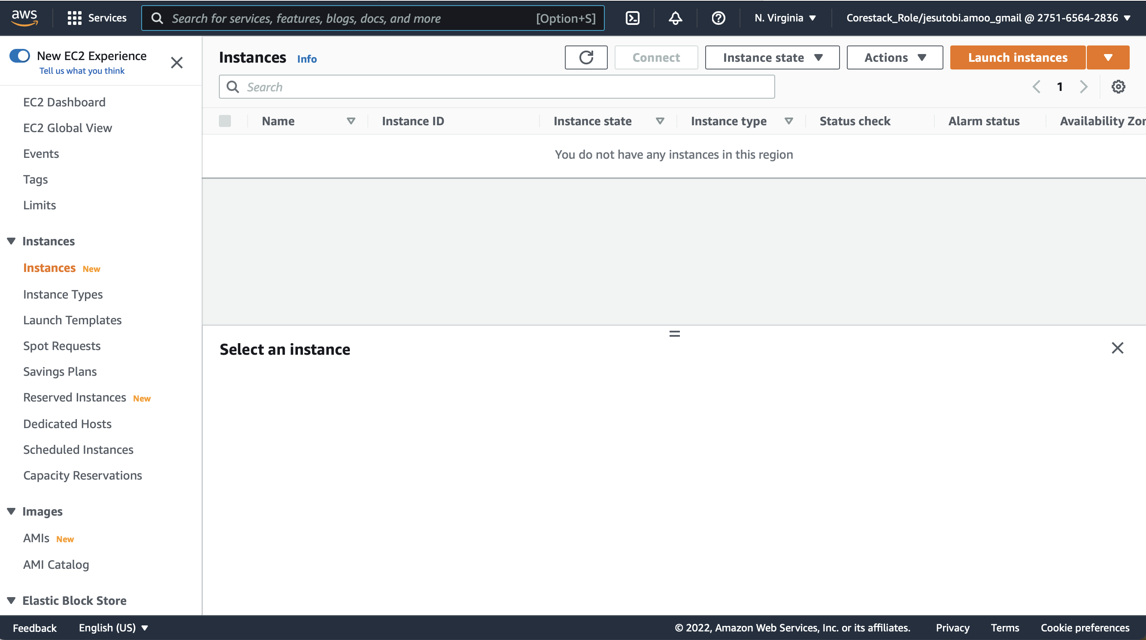

* Select Amazon Linux AMI

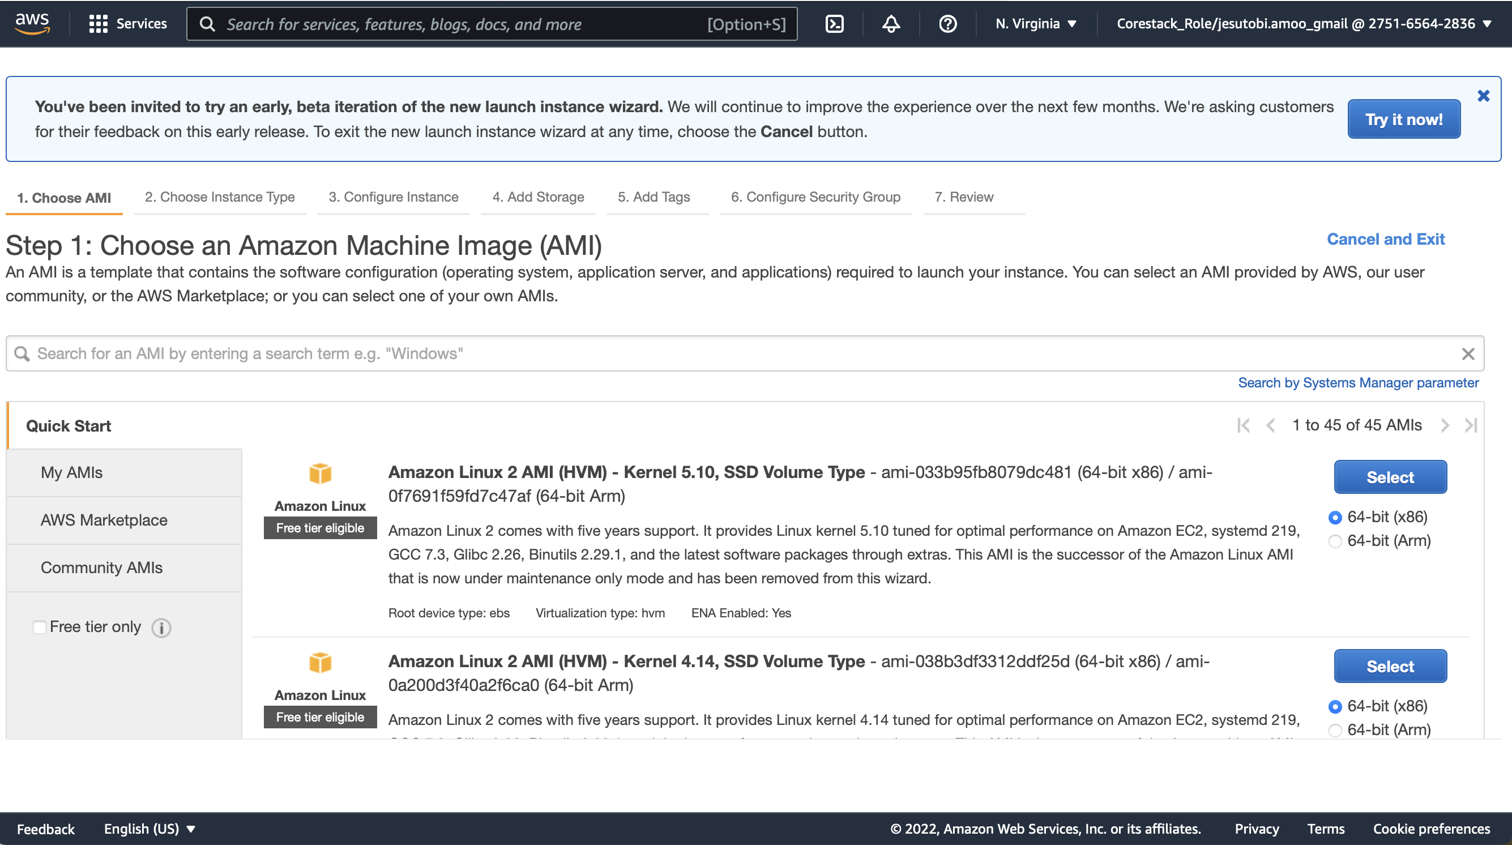

* Select t2micro Instance type

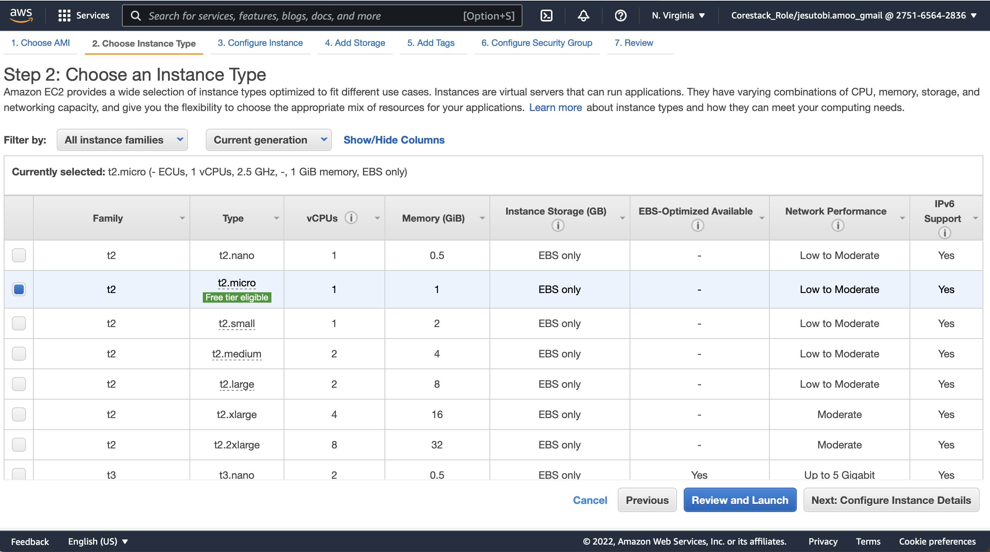

* Copy and paste the below code into the ‘User Data’ section

#!/bin/bash

yum update -y

yum install httpd -y

cd /var/www/html

echo "VM to DB Connect" > index.html

service httpd start

chkconfig httpd on

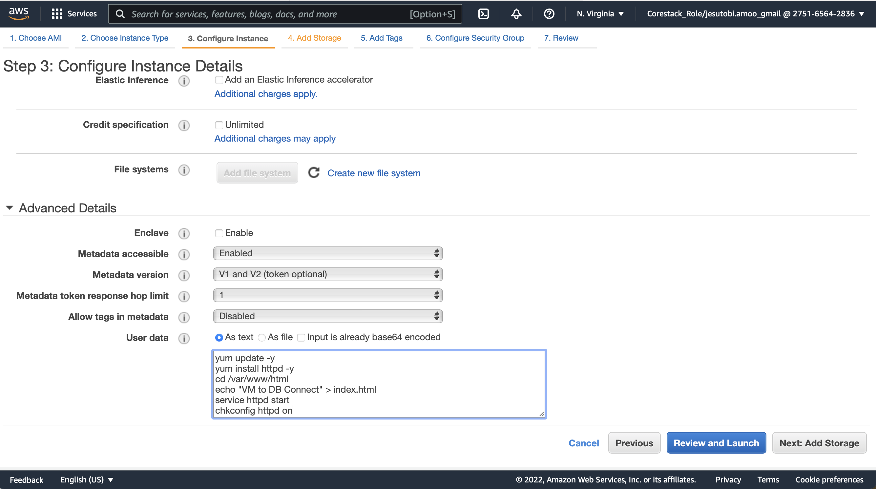

* Click on Add Storage
* Click on Configure Security Group

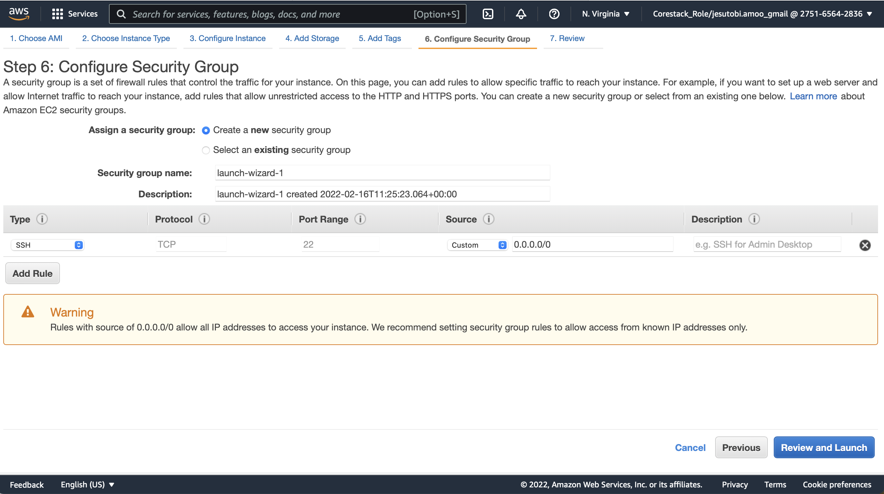

* Click on Add 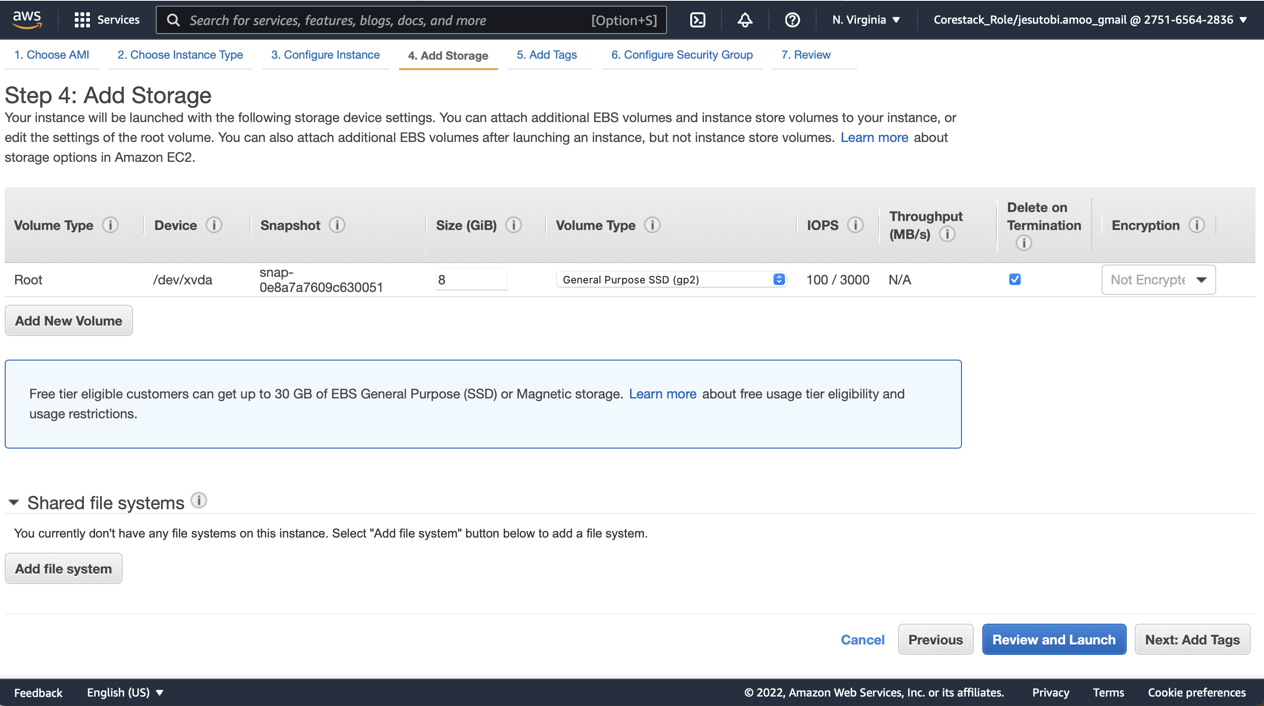New Rule and add HHTP and HTTPS as new rules
* Click on Launch Instance

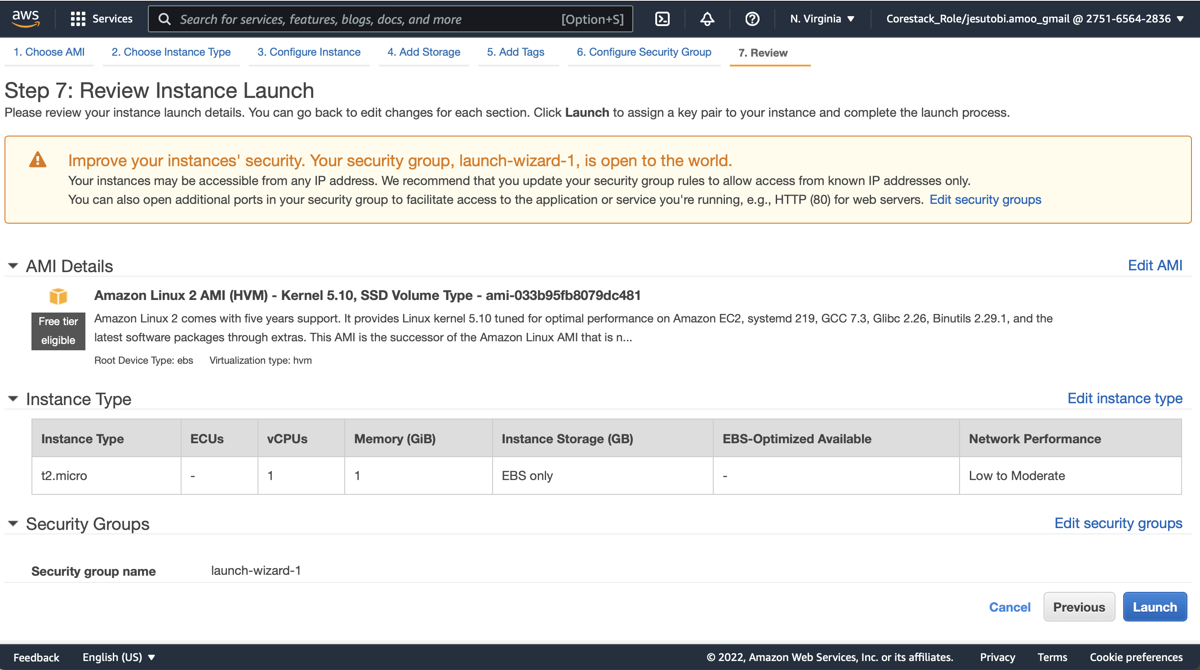

* Click Laun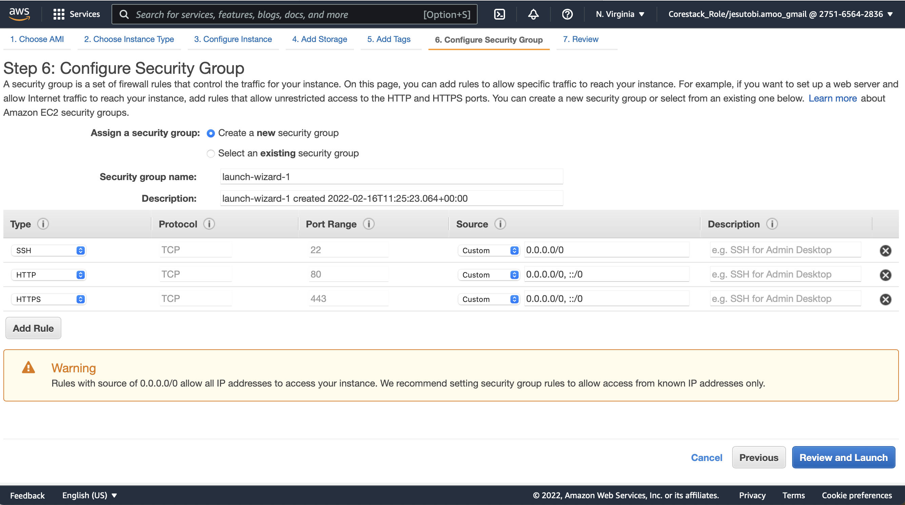ch, create and download new key pair.

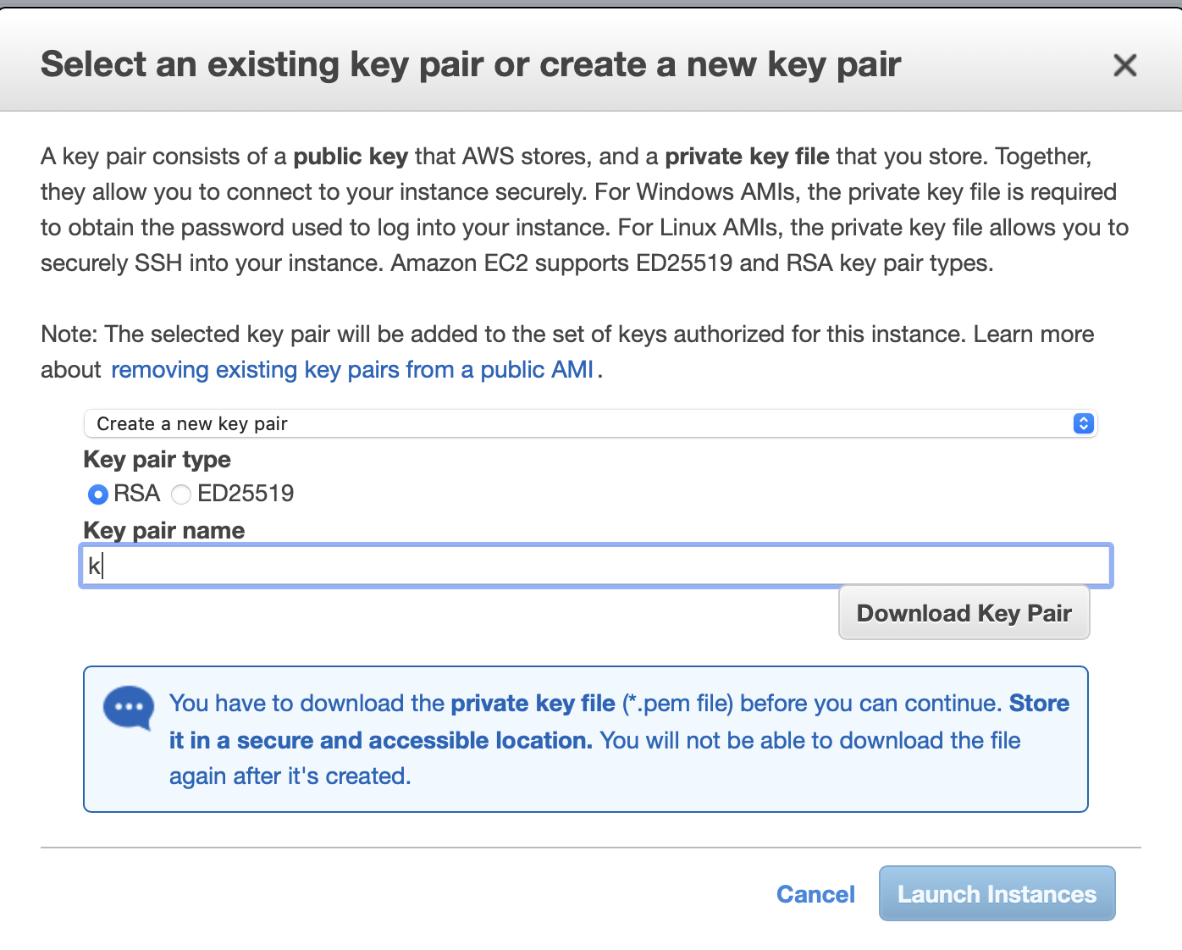

* Click Launch Instance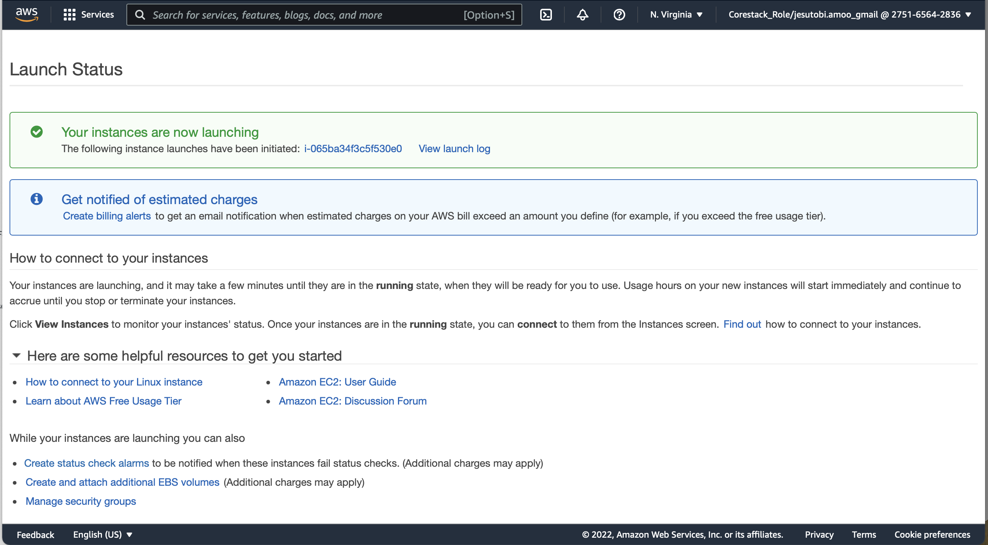
* Click on View Instance

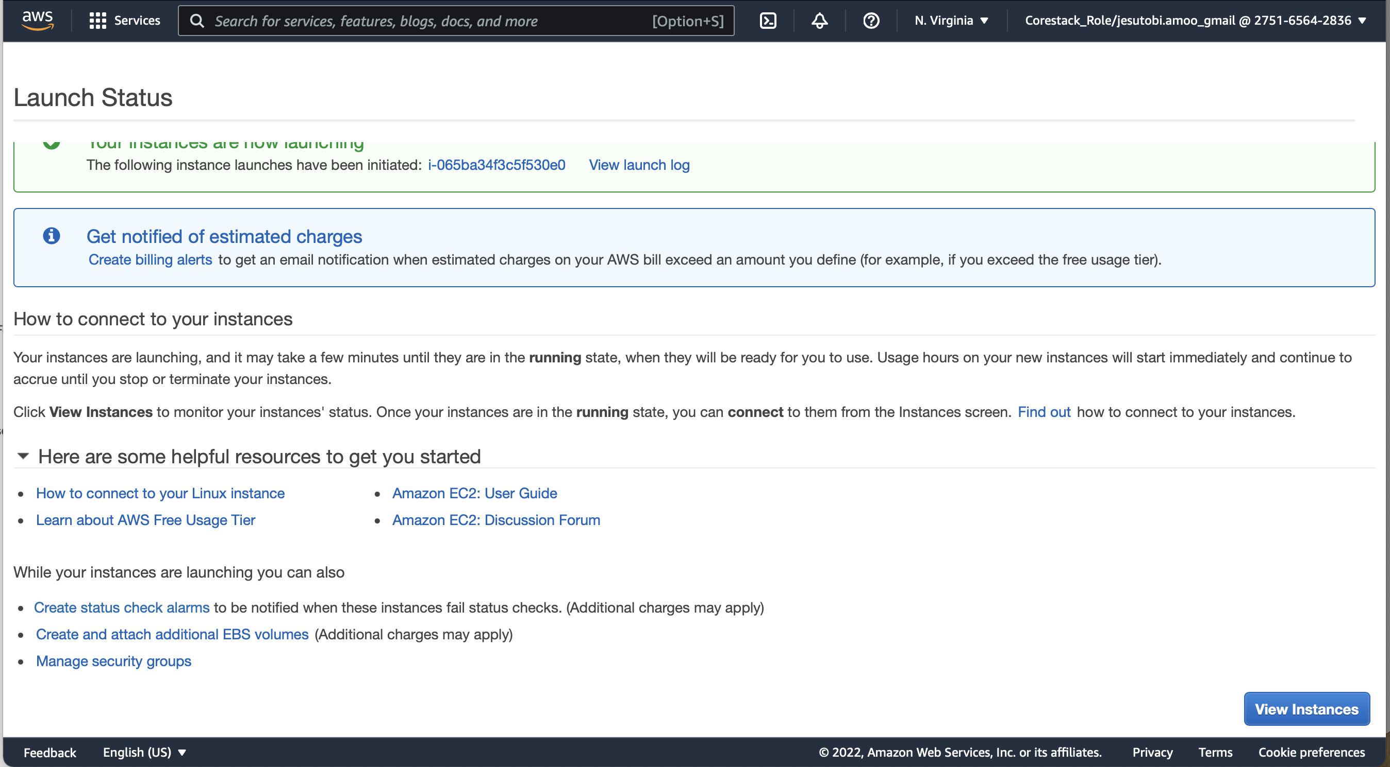

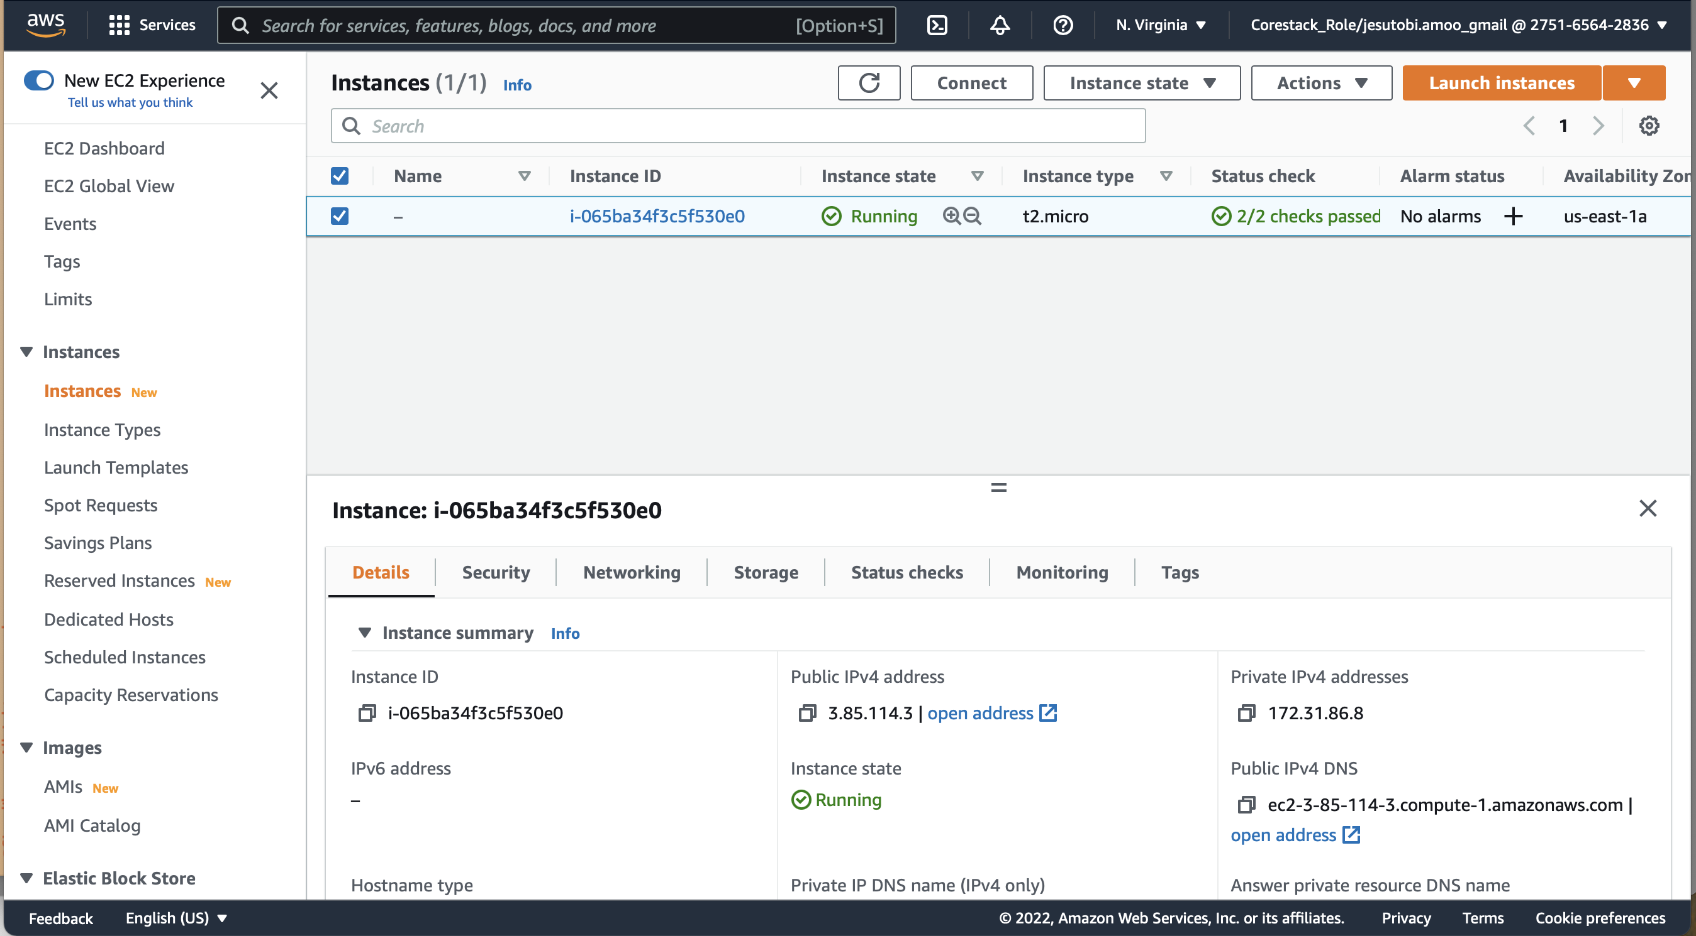

* Select the Instance
* Copy the Public IPv4 address

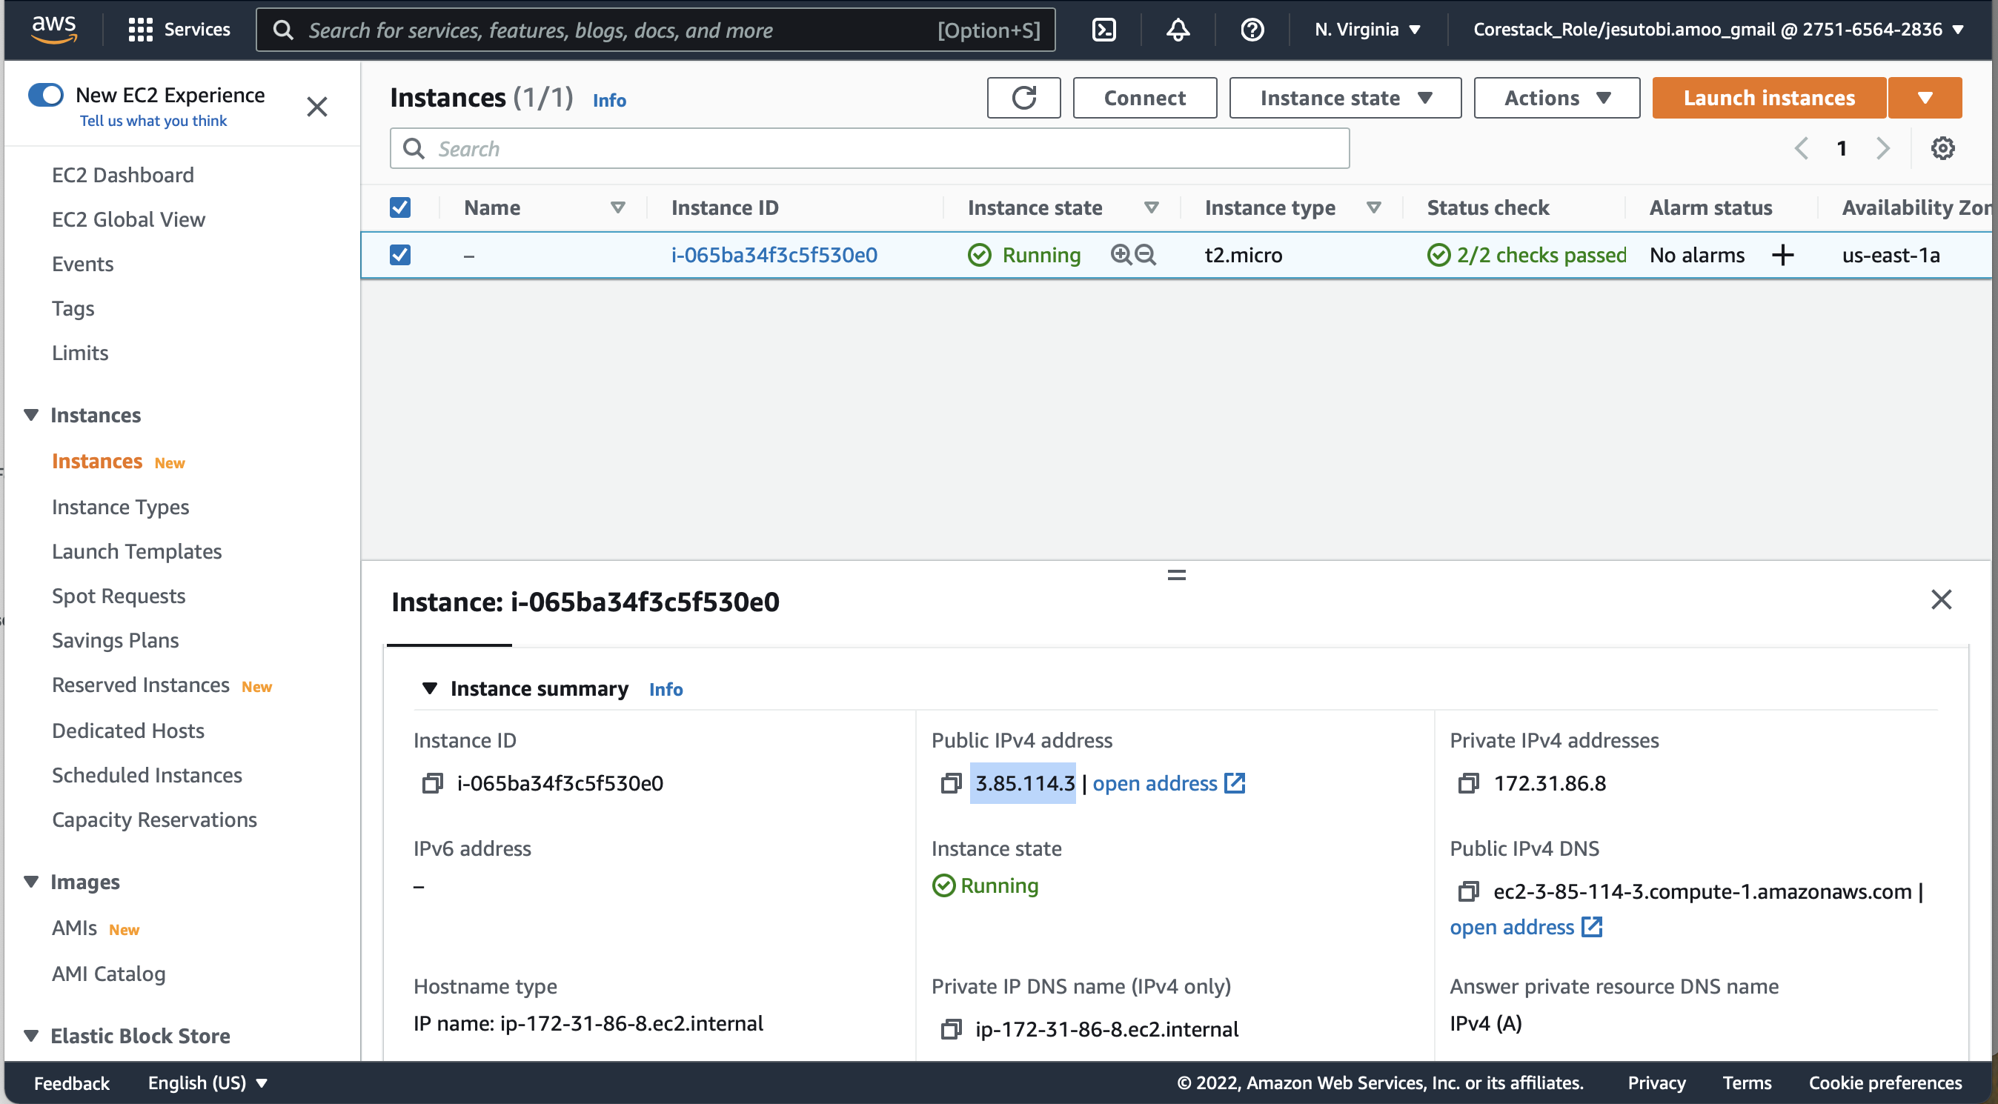

* Paste the IPv4 address into a browser window

